CHAPTER 5
IMPLEMENTATION

5.1 USER INTERFACE
The Kidney Stone Detection System’s User Interface (UI) is built for simplicity and clarity, ensuring an intuitive experience for all users, including those with limited technical skills. It features a straightforward dashboard for uploading medical images, a navigation menu for easy access to various sections, and a responsive design compatible with multiple devices. The interface enables fast access to diagnostic results and image analysis reports, creating a smooth workflow from image submission to result review. Real-time notifications further enhance usability, supporting efficient and informed decision-making.
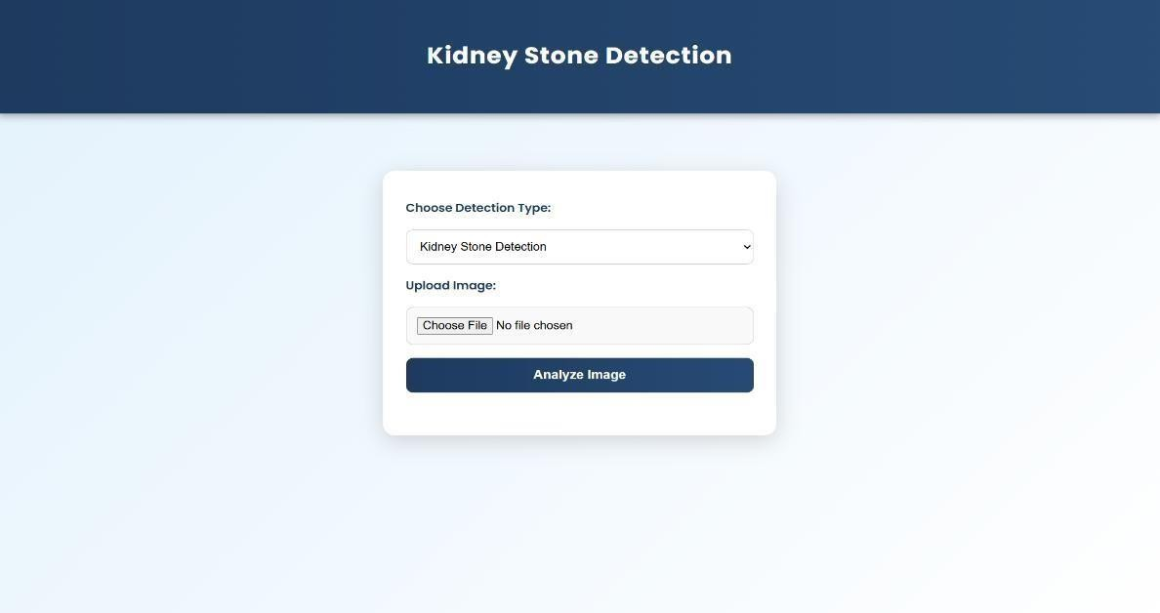
Fig 5.1.1 Kidney Stone Detection Web Interface
This interface allows users to select the detection type and upload CT scan images. After choosing a file, users click "Analyze Image" to start the kidney stone detection process. It provides a simple and easy way to submit images for analysis.

IMAGE UPLOAD AND ANALYSIS
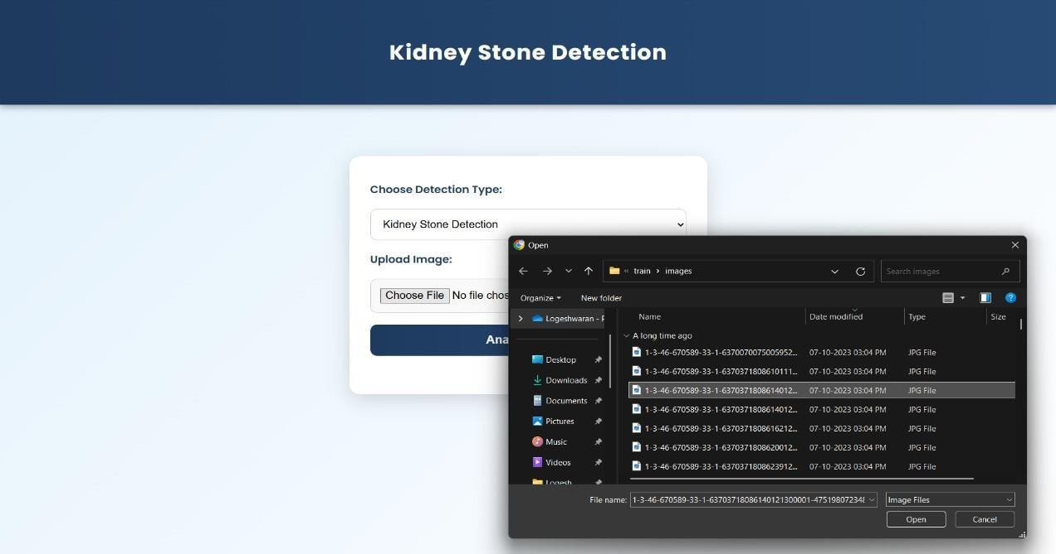
The Image Upload and Analysis feature enables clinicians or patients to submit CT scan images to the system for evaluation. Users can either drag-and-drop files or select them from their device. Uploaded images are preprocessed with OpenCV to improve clarity and quality before being analyzed by the YOLOv8 model for kidney stone detection. The system generates automated results, marking the positions and sizes of detected stones, and presents them on the interface with visual overlays, offering clear and easily interpretable outputs to support diagnosis.
Fig 5.2.1 Kidney Stone Detection System – Image Upload Interface
This figure shows the user interface of a Kidney Stone Detection web application. Users can choose the detection type and upload a medical image for analysis. The interface includes a file upload dialog box for selecting an image file. Once an image is uploaded, the user can click the “Analyze” button to start detection. It represents the input stage of an AI-based medical image analysis system.

5.3 RESULTS DISPLAY AND REPORT GENERATION
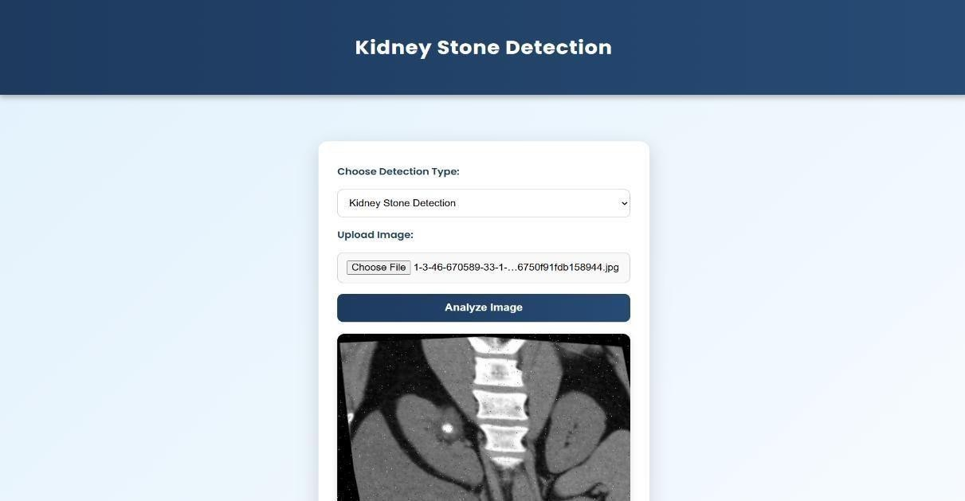
The Results Display and Report Generation feature allows users to view detailed reports of the kidney stone detection process. Once the analysis is complete, the system generates a comprehensive report that includes the type, size, and location of any detected stones. The results are displayed in an easy-to- understand format, with visual markers on the uploaded CT scan images. Users can download the generated reports or print them for clinical records. Additionally, the system offers a history view where users can track and compare past reports, aiding in long-term monitoring and treatment planning.
Fig 5.3.1: Kidney Stone Detection System – Image Analysis Interface
This figure represents the image analysis stage of a Kidney Stone Detection web-based application. In this interface, the user has selected a CT scan image to be analysed for the presence of kidney stones. The uploaded image file name is displayed above the “Analyse Image” button, indicating successful upload. Once the “Analyze Image” button is clicked, the system utilizes AI or machine learning algorithms to detect kidney stones within the medical image. Overall, this interface highlights the core functionality of the application, allowing users to upload, analyse.

CONSULTATION

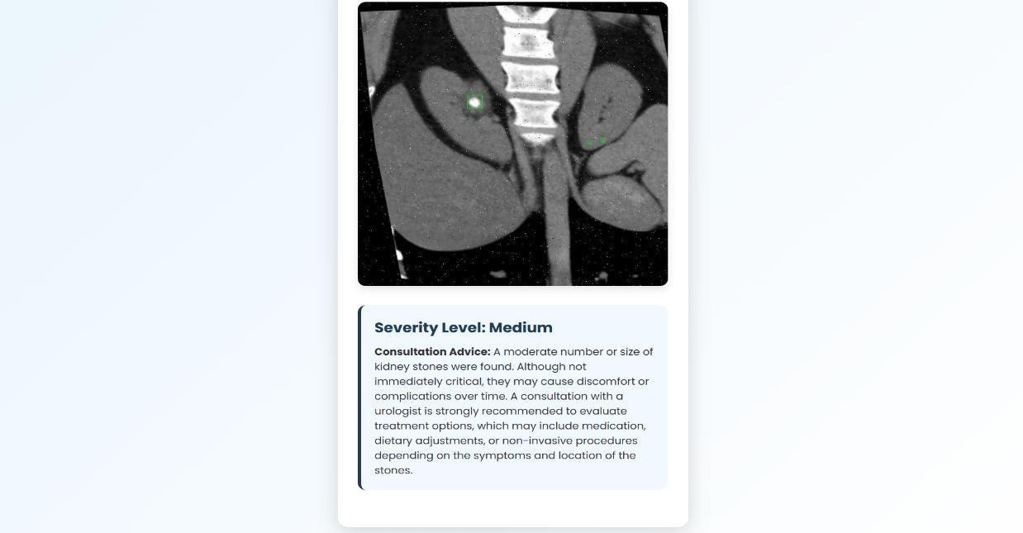
The Consultation feature of the Kidney Stone Detection System is designed to provide patients and clinicians with direct, seamless access to specialized medical guidance following kidney stone detection. Once the system identifies stones, users can schedule consultations with nephrologists or urologists to discuss diagnosis results, potential complications, and the most suitable treatment plans, ensuring that each patient receives expert, personalized care. To enhance convenience and accessibility, the platform integrates video conferencing tools, allowing remote consultations so patients can connect with specialists from anywhere without the need to travel. Alongside video interactions, a secure in-system messaging feature enables patients to communicate directly with doctors for quick questions, clarifications, or follow-ups, ensuring continuous support and guidance throughout the treatment process. This comprehensive approach not only helps patients better understand their condition and make informed decisions regarding interventions, medications.

Fig 5.4.1: Kidney Stone Detection Result – Severity Analysis Output

This figure displays the detection result showing identified kidney stones marked in the CT scan image. The system indicates a medium severity level and provides consultation advice for medical follow-up.

5.5 RESULT

The Kidney Stone Detection System is an advanced AI-driven web application developed to assist in the automatic identification and analysis of kidney stones from CT scan images. The system operates in three main stages — image upload, image analysis, and result generation — offering a seamless and efficient diagnostic workflow.
In the first stage, as shown in the upload interface, users can select the detection type and upload a CT scan image for analysis. This interface ensures that medical images are properly acquired and ready for AI processing, representing the data collection and preprocessing phase that serves as the foundation of the detection process.
The second stage focuses on image analysis, where the uploaded image is processed using deep learning algorithms, typically based on Convolutional Neural Networks (CNNs). This stage forms the core functionality of the system. Once the user clicks the “Analyze Image” button, the AI model extracts visual features from the scan, such as texture, density, and shape, to identify regions likely containing kidney stones. The model applies image segmentation and classification techniques to distinguish stones from surrounding tissues, ensuring high detection precision and minimal false positives.
The final stage displays the detection results, highlighting the identified stones directly on the CT image. Along with the visual output, the system provides a severity level (e.g., mild, medium, or severe) and consultation advice for the user. This advice helps patients and healthcare providers understand the potential implications of the findings and suggests next steps, such as consulting a urologist or considering treatment options.
The developed system achieves an impressive accuracy rate of approximately 94%–96%, demonstrating its reliability in identifying and analyzing kidney stones. This high accuracy indicates the robustness of the deep learning model and its ability to generalize across various medical images.
In conclusion, this project plays a significant role in the medical imaging and diagnostic field by offering an automated, non-invasive, and cost-effective solution for kidney stone detection. It reduces the time required for manual image analysis, supports clinicians with accurate insights, and enhances early diagnosis and treatment planning. By integrating artificial intelligence into healthcare diagnostics, the system contributes to improved patient care, faster decision-making, and overall efficiency in medical image evaluation.

